[](https://www.bing.com/images/search?q=silver+sponsor&id=45A34805A3C9ACF5C7B7D864225C31B4B821F328&FORM=IQFRBA)[](https://www.bing.com/images/search?view=detailV2&ccid=6YHHSH1K&id=2F34F8E38F40FE960B83CAC66C53B49A5539F8A2&thid=OIP.6YHHSH1Kp8SRpw3G3pmsHwGLCe&q=thank+you+sponsors&simid=608032560561850723&selectedIndex=27)

[](https://www.bing.com/images/search?q=gold+sponsorship&id=A50544890290FA45A20800C13E90D3C3AC17A845&FORM=IQFRBA)[](https://www.bing.com/images/search?q=platinum+sponsorship&id=E9D90237FF56B4EDDEFF36F8BEE6368BDC86DDAE&FORM=IQFRBA)

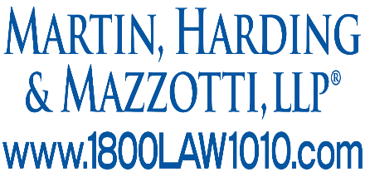[](http://collettmechanical.com/)[](http://bpipiping.com/home.aspx)

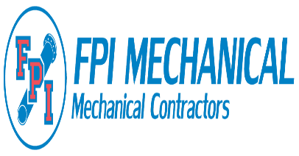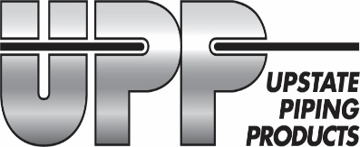

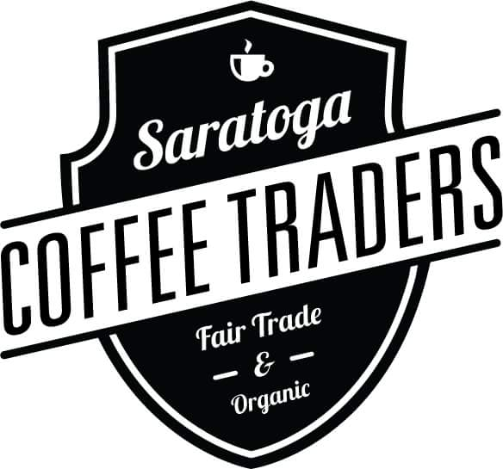



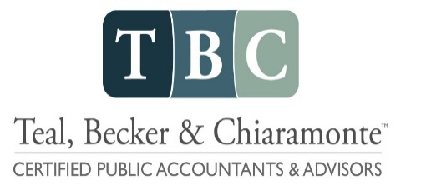

Djordjo Zotovic

Albany Metal Fabrication

**Marty Furlong**

**[](https://www.bing.com/images/search?view=detailV2&ccid=GyD31%2bt6&id=4F354B36BCA2F7242B181DED87F49A376FE3841A&thid=OIP.GyD31-t6lvZZx1jU1_yLGQEsCD&q=nutricia&simid=608001130001862355&selectedIndex=0)[](http://www.cambrooke.com/)Vendor Sponsorships:**

